Blind Docking of Catechin Gallate against SARS-CoV-2 Main Protease

(Mpro; PDB 6LU7)

# Abstract

We evaluated catechin gallate (PubChem CID 6419835) as a putative inhibitor of the SARS‑CoV‑2 main protease (Mpro). A cleaned receptor (6LU7 chain A) was prepared in PyMOL and blind docking was performed with CB‑Dock2. The top pose achieved a Vina score of −7.6 kcal/mol in Pocket 1 and located within the catalytic cleft near His41/Cys145. Predicted ADMET properties were summarised from SwissADME, pkCSM and ProTox‑II: SwissADME reported low GI absorption with no CYP inhibition flags; pkCSM predicted ~62% intestinal absorption and a hERG II alert; ProTox‑II indicated toxicity Class 4 with LD50 ≈ 1000 mg/kg. Overall, docking supports a plausible non‑covalent pose for catechin gallate with manageable liabilities; experimental enzyme inhibition and safety profiling are required for confirmation.

# 1. Background

SARS‑CoV‑2 Mpro (3CLpro) is a cysteine protease that cleaves viral polyproteins into functional units essential for replication; it is often described as the virus’s “scissors”.

Because humans lack closely related homologs, Mpro is a therapeutically attractive target for small‑molecule inhibition.

Catechin gallate is a polyphenolic scaffold. Here, we explored its ability to bind Mpro via blind docking and summarised predicted ADMET liabilities.

# 2. Materials and Methods

## 2.1 Inputs

Receptor: 6LU7 chain A cleaned (waters and N3 removed; hydrogens added) saved as B:/mpro_docking_project/input/MproA_clean.pdb.

Ligand: catechin gallate (3D SDF; PubChem CID 6419835) saved as B:/mpro_docking_project/input/catechin_gallate.sdf.

## 2.2 Tools

Visualisation: PyMOL 3.x (trial).

Docking: CB‑Dock2 (Auto Blind Docking; default 5 cavities).

ADMET: SwissADME, pkCSM (ADMET), ProTox‑II.

## 2.3 Procedure (summary)

• Fetched and cleaned 6LU7; generated receptor object MproA_clean.

• Ran CB‑Dock2 blind docking with the cleaned receptor and catechin gallate (3D SDF).

• Downloaded results; retained highest‑ranked pose and saved as B:/mpro_docking_project/docking/top.pdb.

• In PyMOL, rendered standard figures and selected pocket residues within 4 Å of the ligand; exported residue list to pocket_residues.csv.

• Generated ADMET predictions and captured screenshots from each tool.

## Figure 1. Global view

*Overall view of Mpro (cartoon, slate) with catechin gallate in sticks, showing the ligand seated in the substrate cleft.*

## Figure 2. Pocket zoom

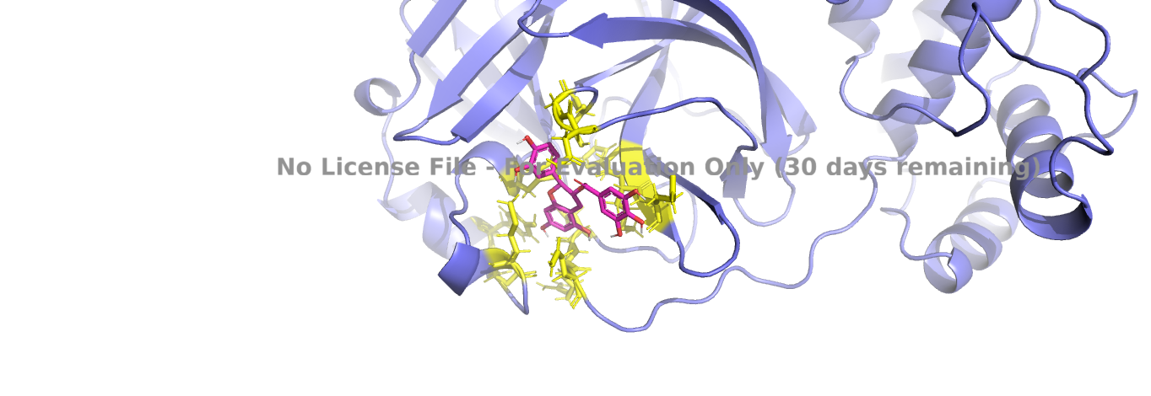

*Close-up of residues within 4 Å of the ligand (yellow sticks); key contacts include His41, Cys145, Met49, His164, Met165, and Glu166.*

## Figure 3. Surface view

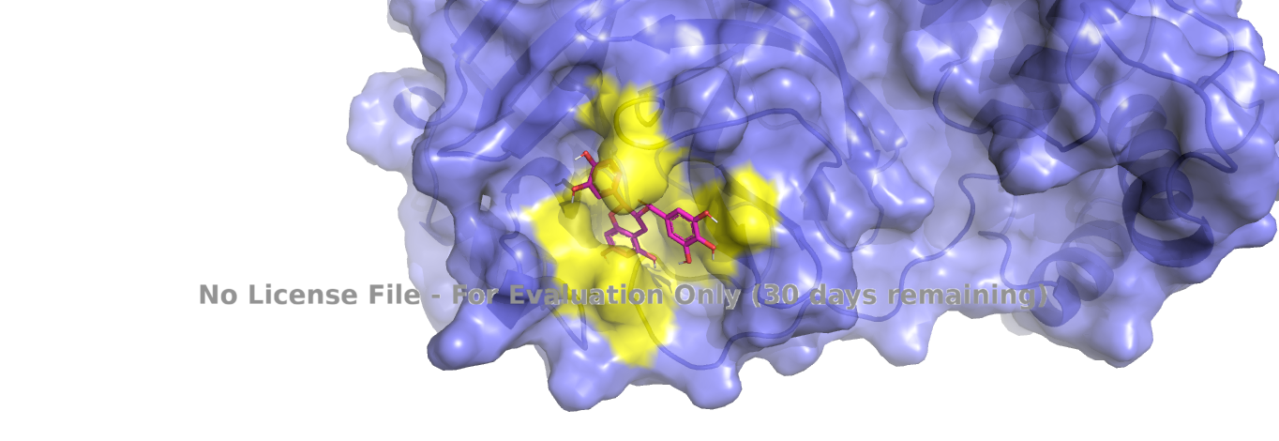

*Semi-transparent molecular surface (0.2) enclosing the ligand, illustrating pocket enclosure and access channel.*

# 3. Results

## 3.1 Docking summary

|  |  |
| --- | --- |
| Best Vina score (kcal/mol) | −7.6 |
| Cavity / pocket (CB‑Dock2) | 1 |
| Pose file used | docking/top.pdb |
| Key nearby residues (≤6) | His41, Cys145, Met49, His164, Met165, Glu166 |
| Residue list file | report/pocket_residues.csv |

Interpretation: As shown in **Fig. 1–3**, the ligand occupies the canonical substrate groove, with polar proximity to Glu166 and hydrophobic packing toward Met49/Met165, consistent with the −7.6 kcal/mol score.

## 3.2 ADMET snapshot

SwissADME: GI absorption Low; BBB permeant No; P‑gp substrate No; CYP1A2/2C19/2C9/2D6/3A4 inhibition all No; Lipinski Yes with 1 violation (NH or OH > 5); Bioavailability score 0.55; Log Kp −7.91 cm/s.

pkCSM: Intestinal absorption 62.096 %; P‑gp substrate Yes, inhibitor I No, inhibitor II Yes; BBB log BB −1.847; CNS log PS −3.743; Hepatotoxicity No; AMES No; hERG I No / hERG II Yes; Max tolerated dose 0.449 log mg/kg/day; Oral rat LD50 2.558 log mol/kg; LOAEL 2.777 log mg/kg_bw/day; Total clearance −0.169 log ml/min/kg; Renal OCT2 substrate No.

ProTox‑II: Toxicity Class 4; predicted LD50 1000 mg/kg; several endpoint models labelled Active (exploratory).

Synthesis: Absorption predictions are mixed (SwissADME low vs pkCSM ~62%); BBB penetration is unlikely; CYP liabilities appear minimal; a pkCSM hERG II alert suggests cardiac safety should be checked experimentally.

## Figure 4. SwissADME panel

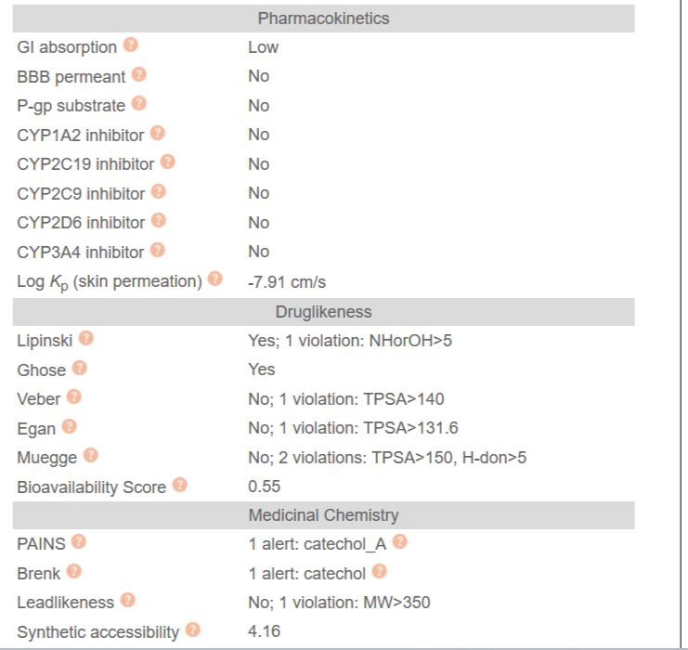

*Selected SwissADME outputs: GI absorption (Low), Lipinski (Yes; 1 violation), and CYP inhibition (all No).*

## Figure 5. pkCSM panel

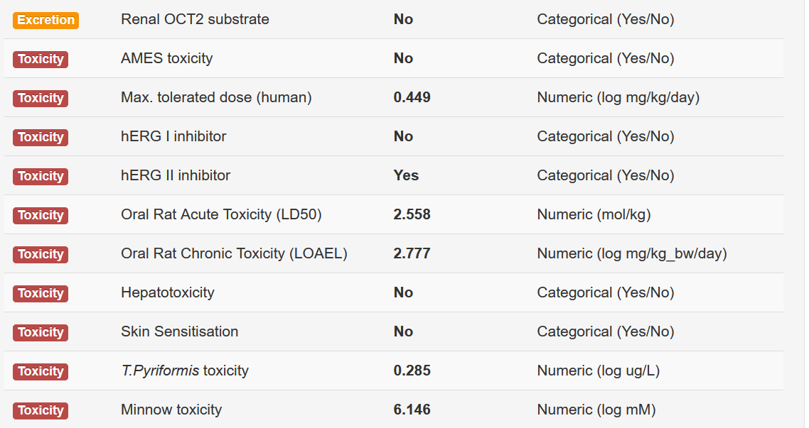

*Selected pkCSM outputs: intestinal absorption (~62%), BBB/CNS low permeability, and a hERG II inhibition flag.*

## Figure 6. ProTox‑II panel

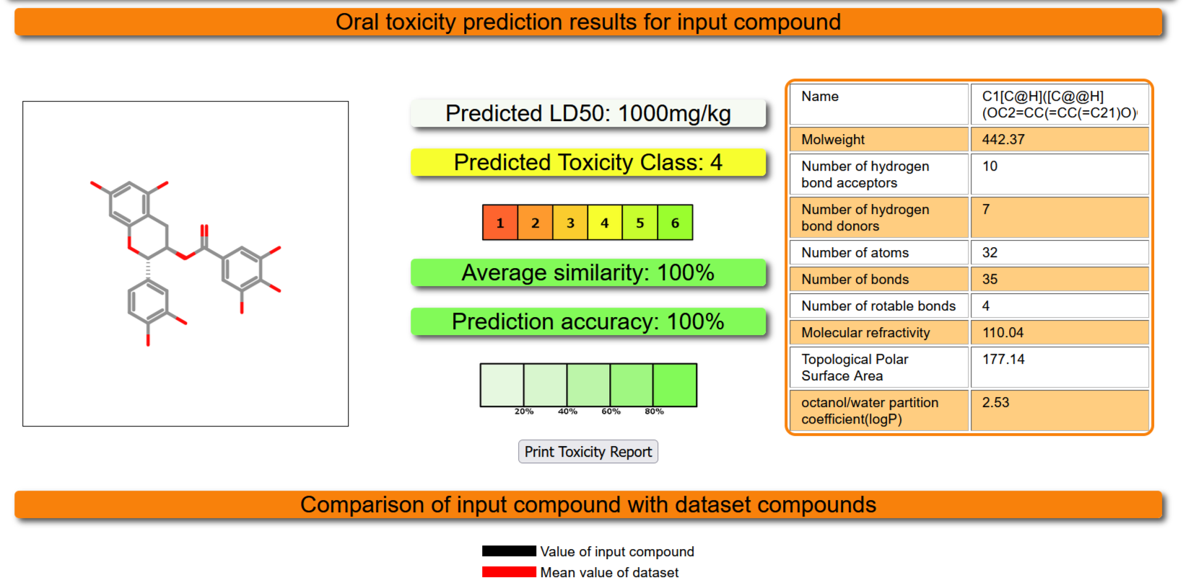

*ProTox-II classification (Class 4) and predicted LD50 (1000 mg/kg).*

# 4. Discussion

The top‑ranked pose occupies the canonical substrate‑binding region of Mpro and is geometrically compatible with non‑covalent engagement of the catalytic dyad. Hydrogen‑bonding capacity from the polyphenolic groups can support polar contacts, while aromatic rings can contribute to hydrophobic packing near Met49 and Met165.

ADMET predictions are broadly acceptable for an early hit: low propensity for CYP‑mediated drug–drug interactions and low likelihood of central exposure. The hERG II alert warrants orthogonal validation (e.g., patch‑clamp or high‑throughput hERG assays) before progression.

Vina scores rank poses within a fixed protocol and should not be over‑interpreted as absolute binding energies; nonetheless, the −7.6 kcal/mol value is consistent with micromolar‑range hypotheses typical of screening hits.

# 5. Limitations

• Single crystal conformation (6LU7) was used; protein flexibility and induced fit were not modelled.

• The docking engine and parameters were not cross‑validated with alternative methods or rescoring.

• ADMET tools provide in‑silico estimates and should be considered hypothesis‑generating rather than definitive.

# 6. Conclusion

Catechin gallate presents a plausible non‑covalent pose in Mpro Pocket 1 (−7.6 kcal/mol) proximal to the His41–Cys145 dyad, with limited CYP liabilities, low CNS likelihood, and a pkCSM hERG II flag. These results motivate enzyme inhibition assays and safety screens to validate and refine this hypothesis.

# Acknowledgements / Data Availability

Structures and predictions derived from: RCSB PDB (6LU7), PubChem (CID 6419835), CB‑Dock2, SwissADME, pkCSM, and ProTox‑II. Local files: input/MproA_clean.pdb, input/catechin_gallate.sdf, docking/top.pdb, report/pocket_residues.csv, and the image files listed above.